Hidden treasures await all those who browse the archives of the Luigi Silva Collection at the University of North Carolina at Greensboro, one of the five Cello Collections owned by UNCG’s Jackson Library <http://library.uncg.edu/depts/speccoll > which also include the collections of Elizabeth Cowling, Maurice Eisenberg, Rudolf Matz and János Scholz.
The value of this largely untapped source of cellistic and musical information hidden in the Silva archives lies primarily in its wealth of detail. It may be the single most comprehensive storehouse of information about the cello, its history, technique, pedagogical theories and aesthetic and psychological analysis gathered under one roof. Not since Edmund vander Straeten’s History of the Violoncello (London: W. Reeves, 1915, reprint 1971) and Wilhelm Wasielewski’s The Violoncello and its History (London and New York: Novello, 1894, English translation by Isobella S. E. Stigand, reprint by Da Capo Press, 1968) has such an exhaustive history of cellists and cello-composers been attempted. Silva’s writings cover not only history, but also pedagogy, musicological resources and include in depth analyses of treatises for other instruments than the cello. Supportive material includes numerous exercises and musical examples either created or gathered by Silva.

Luigi Silva, Biography
Luigi Silva (1903-1961) was a cellist and true Renaissance man. His many hats included performer, pedagogue, transcriber, musicologist/scholar, and writer. He was literate in at least six languages.
Born in Italy into a musical family, he began his study of cello at age eight. His teachers included Arturo Bonucci in Bologna and Luigi Forino (1868-1935) in Rome. He received both a cello performance degree and a masters degree in music pedagogy (1921) from the Bologna Conservatory.
Silva performed throughout Europe in the 1920s and 1930s, where he played in the Rome Opera orchestra and the Quartetto di Roma. In 1939 he immigrated to the United States, settling first in California and later in New York. From 1941-1949 he was head of the cello and chamber music departments at Eastman School of Music and after 1949 taught at Julliard, Mannes, and Yale. During the 1950’s he taught at no fewer than five major music schools, adding both The Peabody Institute of Music and Hartt College (Hartford CT) to his roster. He also performed with the Mannes-Gimpel-Silva Trio.

Bronislav Gimpel, Leopold Mannes, Luigi Silva

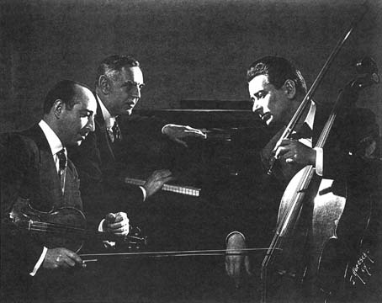

Transcriptions
Silva’s transcriptions include six pedagogical works and some 23 published scores. He had also planned to produce a complete edition of the Boccherini sonatas. Twenty-three of these exist in manuscript in Silva’s hand, and eight (G.1, G. 4-6, G. 10, G. 13, G. 17 and G. 566) have fully realized keyboard parts. Although Silva had a life-long interest in Boccherini and did extensive research in the libraries of Paris, Florence and London that own autographs and early editions of Boccherini’s works, his dream of publishing these editions was unfortunately not achieved in his lifetime. A complete list of Silva’s published transcriptions for the cello is available in the Silva Archives at UNCG. < http://library.uncg.edu/depts/speccoll/cello/>

Silva’s writings
In his papers and notes, Silva left a veritable feast for performers, teachers and researchers. His pedagogical writings cover all levels of performance. Always stressing the practical solution in combination with artistic sensibility, he emphasized mental processes in preparing and playing. Silva himself had been told by one of his early teachers that his hands were too small for the cello and that he should probably consider another instrument. Possibly for this reason he was particularly determined to teach students how to adapt their particular technical approach to the cello to their physical characteristics in order to achieve the optimum ease in playing. This determination may also have spurred him to do his extensive research on anatomy. Some of the writing he collected on this topic would be helpful to anyone suffering from a shoulder or joint injury. He left sketches of the hand, illustrating his theories of movement.

Sketches of hand

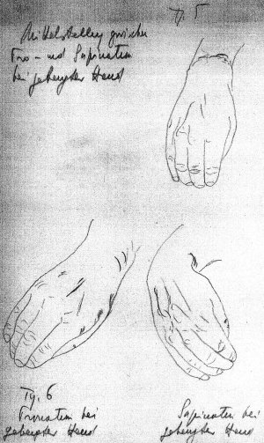

Perhaps Silva’s greatest strength lay in his ability to develop talent in young cellists. At the time of his death he had two major pedagogical works in progress: Vademecum, a comprehensive teaching manual for left and right- hand technique, and La Tecnica Violoncellista or Storia, translated and edited by Margery Enix as A History of Left-hand Technique on the Violoncello, which remains unpublished. In addition he left several shorter papers in various states of completion on topics as varied as bowings in the Bach cello suites and the teaching of string instruments to beginners.

Collaboration with Matz
Silva had a deep respect for his contemporary, the Croatian-born cellist, Rudolf Matz (1901-1988). He and Matz worked together on an outline for a cello method. Matz did in fact publish his own method, Prve godina violoncella (The First Years of Violoncello), first published in Zagreb by Nakladni zavod Hrvatske and others between 1947 and 1966 in 32 sections, later revised and expanded to include 40 units, published by Dominis Music (Ottawa, Ontario), beginning in 1979. Material from these volumes was planned for inclusion in the Matz/Silva Method. It is unclear from Silva’s papers which of his own many exercises and musical examples were earmarked for this collaboration. Some correspondence between Matz and Silva indicates that Matz was concerned that this project might never be completed.

Encyclopedia of Bowed String Instruments
Another massive project Silva planned but never lived to complete was an Encyclopedia of Bowed String Instruments. The range of topics listed in the table of contents is staggering. Among them are the evolution, performance, pedagogy, and literature of the instruments as well as a biographical dictionary of string instrument performers. A complete listing of these topics is available from the Archives. <http://library.uncg.edu/depts/speccoll/cello/ > Long bibliographical lists of cello methods in collaboration with his former student, Elizabeth Cowling, cello professor from 1945-1976 at UNCG, whose cello collection is also among the five found at the Special Collections and Archives, and Joan Mack, another of Silva’s former students, were probably slated for inclusion in this Encyclopedia. Lists are organized both
chronologically and by region, as well as alphabetically.

VADEMECUM
Silva’s most comprehensive work left uncompleted at his death is Vademecum. This was designed as an encyclopedia or handbook of cello technique. This choice of title, often used in the medical fields, reflects Silva’s life-long interest in the connection between the study of anatomy and the physical/technical aspects of performance. He began work on this rich archive of information about the cello while in his twenties and continued off and on over the next three and a half decades of his life. This work was written first in Italian and later partially translated into English, with the help of one of his students from the early forties, Vance Beach. The table of contents includes a preface, which survives in Italian with only fragments translated. Following the preface is an annotated bibliography of technical works for the cello, also listing sources in various languages for the exercises Silva collected. A second bibliography covers methods, treatises and theoretical works.

Volume 1, Left hand technique
Vademecum is organized in six volumes with ten parts. Volume 1, part 1, covers left-hand technique. A large body of material in English exists for the sections concerning independence, strength and flexibility of the fingers, in particular on what Silva terms “elementary independence.” He comments, “The study of technical exercises may be compared to athletic training.”
Under the heading, “absolute independence,” lateral (horizontal) and vertical (dropping and lifting) movements are discussed. Silva often refers to two basic left-hand positions or postures, the “pianistic” (horizontal), involving extensions, and the “violinistic” (vertical or oblique), an older style used up to Romberg. He approaches his analysis from these two opposing points. Both, he believes, are appropriate in their place.

Absolute Independence

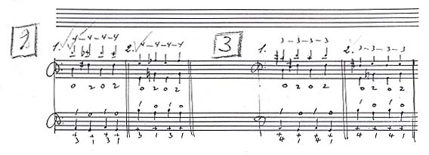

The sections on “independence in arranging the fingers in thumb position” and
“gymnastics for the flexibility of the fingers” are in both Italian and English. Long passages in English are available on the independence of three and four fingers and development of lateral movement in two fingers.

Independence of fingers in thumb position
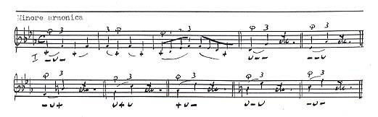

His closing statement, “Ultimately it will be the means of doing away with the present methods of teaching, which, in my opinion are inclined to increase the difficulties of playing rather than to lessen them,” may refer to the exercises he selected carefully
for insertion in the text or to his overall approach, which was quite flexible and designed to accommodate the individual student.
There are no notes for the next parts of the outline, “independence of pressure”
and “independence between bow and left hand.” A section labeled “Monochord,” refers to 1-finger shifting and includes exercises for:
- Monofinger (1 finger, 1 string)
- Monofingers (2 fingers on 2 alternate strings
- Double stops (“monofinger” (on Silva’s outline))
All of these are to be practiced in both the lower and thumb positions. Material in English covers substitution of fingers on the same string, on two or more strings and in double stops. (See Box 1-10, English typescript, p. [3-4] and Luigi Silva, A History of Left-hand Technique on the Violoncello, translated by Margery Enix, unpublished typescript, 1988, v. 1, p. 129-139.)
Coverage of trills is in both Italian and English. Exercises include:
- Trills with and without the thumb touching the neck
- “To prevent stiffening of the wrist”
- “To prevent stiffening of the finger”

Volume 2, Thumb position
No notes survive for the final section of volume 1: pizzicato. Neither can any writings relating to the entire second volume, “Condensation of the general plan of a method for the thumb-position, “ be located. Since this part of Vademecum is the one most often mentioned in biographical sketches of Silva, it seems odd that none of his notes reflect this. There is, however, a great wealth of musical examples of thumb-position exercises. Snippets excerpted from Boccherini, Haydn, Popper and Dvorak illustrate both the use of the fixed and the extended thumb. (See Box 13-2)

Thumb position exercises

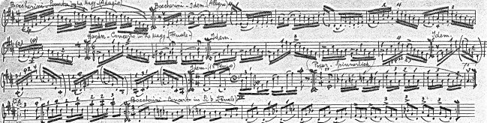

Volume 3, Scales
Silva did leave a great deal of information and numerous exercises on the topic of Volume three, “Scales,” the majority in Italian. He says, “I have made an attempt to exhaust the possibilities of the arrangement of degrees within the 7-tone scale.” Appendix A contains a printed (unpublished) chart of all major and melodic minor scales in four octaves for cello. Silva had an interesting theory about the 4-octave scales, which extend into what he terms “the rosin region.” He did not believe there was any benefit to be gained from practicing these scales into the higher regions; therefore the highest ones don’t always end on the tonic.

Scales
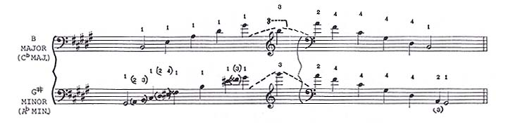

In this section, “Scales,” we find writings about chromatic and modal scales, including a brief history of the modes, and many scalar exercises. The outline stipulates hexatonic, pentatonic, octotonic (9-11 tones), polytonal, plural (5-8 tones), polyrhythmic, polytetrachordal, 12-tone rows and scales according to Busoni. There are examples of rhythmic variants, variants for the study of the bow and for the left hand.

Variants for the bow
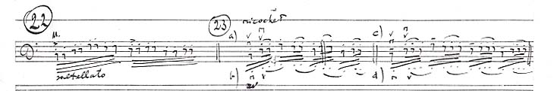

Variants for the left hand

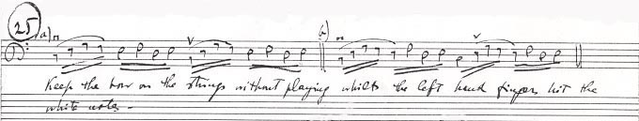

Volume 4, Arpeggios
The information on Volume 4, “Arpeggios,” is rather sketch and mostly in Italian. The outline lists many of the same topics as for the chapter on scales but includes modulating, bitonal, quadritonal, tetratonic, hexatonic and heptatonic arpeggios as well as those based on the whole tone scale. Passages from repertoire include diminished sevenths and various modern arpeggios.

Arpeggios taken from repertoire

Portions in English discuss the concept of closed (major) and open (minor) positions, prolongations of the arpeggio by artificial harmonics and arpeggios on one string. Silva states, “[A] change of position must occur on the first finger on the mediant in ascending and on the second finger on the tonic in descending.” This seems uncharacteristically rigid of him.

Volume 5, Technique of double stops
One of the most extensive sections on left-hand technique is in Volume 5, part 5, on double stops. Silva believed the term “interval” to be misleading and preferred the word “distance” to describe the relationship between two tones. Most of the material is on thirds, tenths, fourths, and octaves. Good musical examples abound for artificial harmonics. (See Box 13-2)

Artificial harmonics

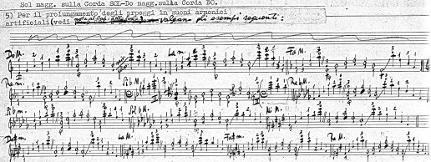

More time is spent studying thirds than sixths, although sixths actually occur more often in the repertoire, according to Silva. He points out that the finger patterns for 4ths are the reverse of those for 6ths. He discusses a type of “slide” fingering which alleviates the problem of the fifth produced across two strings by using the traditional method of adjacent pairs of fingers (e.g. 1 and 2 to 2 and 3).

“Slide fingering”
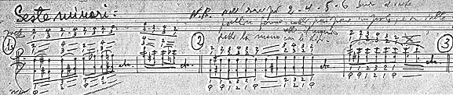

Part 6, Shifting
Volume 5, Part 6, was planned for an extensive treatment of shifting. Unfortunately there is a large gap here, and this topic is covered only minimally. Headings are:
1.Shifts (skips) and portamentos
2. Theory and computation of the distances
3. The B. and L. (bow and left-hand?) portamento (Flesch)
Sprinkled throughout the document are references to shifting, particularly without preparation and to portamento as well as what Silva calls “bow vibrato.”

Volume 6, Bow technique
By far the bulk of the notes Silva left for Vademecum pertain to right-hand technique. Much of this material has been translated. Since he also had in mind to create an Encyclopedia of the Bow, one could speculate for which work these notes were actually intended. However, the sub-headings do follow the outline of Vademecum. Though the outline is very general, the text is full of detail. Volume 6, part 8, covers holding the bow, including the position of each finger on the grip. Here Silva refers to the writings of J.L. Duport, Bernard Romberg, and Alfredo Piatti extensively. In the section on the point of contact, he quotes liberally from Duport’s treatise, Essai sur le doigté du violoncelle et sur la conduite de l’archet (Paris: Imbault, [1806?]), English translation by John Bishop, Essay on fingering the violoncello and on the conduct of the bow (London: Augener, 1878).
Silva discusses the differences in the German and Italian schools of bowing. He also refers to Michel Corrette’s Méthode théorique et pratique pour apprendre en peu de temps le violoncelle dans sa perfection (Paris: Chez l’auteur, 1741. Reprint: Genève: Minkoff Reprints, 1972) for three different ways of holding the bow. Silva believes the point of contact is determined by the individual player and is not absolute. Constant fluctuation of this point is not considered a “contradiction” (i.e., a flaw) as long as it is deliberate.
Four factors he considers in choosing the point of contact are:
- Strength of left hand
- Strength of right hand
- Type of bow hold: “advanced”; (i.e., pronated) or “retarded”; (i.e., supinated)
- Length of end pin
(For further information see Box 1-10, English typescript, “Paragraph I”, p. [5])
He also contrasts various theories of tone production including those of Carl Flesch, Lucien Capet, and Sarge Barjansky (The physical basis of tone production for string instrument Players (Pittsburgh: Volkwein Bros., 1941).
Silva has some very detailed sets of rules for the drawing of the bow. He deals with bow speed and its relationship to bow pressure; he maintains that the speed of the bow is greater for the up than for the down bow. He refers to Leopold Auer’s theory that the bow speed affects the pitch of a tone.
Exercises Silva contributed for the right hand involve lifting various combinations of fingers from the stick including:
- The index
- Both index and little finger
- Middle and ring fingers
- Alternating two middle with index
- Alternating two middle with little finger
- Alternating all combinations of above on the down and up bows
There are exercises for deliberately changing the point of contact and for the “archet roule” (rolled or turned bow), which develops smoothness and flexibility of fingers. Silva suggests practicing two types of articulations: alternating (stationary playing axis, little finger presses down while index finger pulls up) and simultaneous (up and down movement of the playing axis, thumb and second finger touch; thumb moves upward toward palm while second finger bends at all joints). The choice is affected by the position of the wrist and somewhat by the degree of finger articulation.
Finger articulations for changing strings and for playing chords created by Silva or derived from sources such as F.A. Steinhausen, Duport, Romberg, Friedrich Grutzmacher and Hugo Becker pepper the collection. Silva left several charts on bowings in various states of completion.

Bowing chart

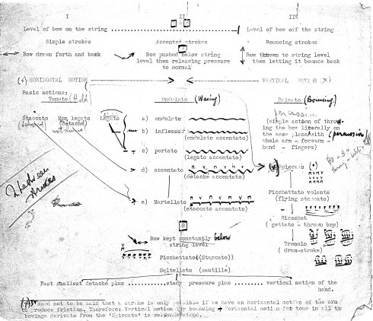

It is interesting to compare the numerous drafts on bow levels and common bow strokes. There are charts of scale bowings with examples from Diran Alexanian, Paul Bazelaire, J. J. F. Dotzauer, Grutzmacher, Piatti and Giovanni Battista Viotti. These include examples of arpeggios and chords in a variety of rhythms and bowings. Additional detail on the writings of string pedagogs such as Nicolo Paganini, Giuseppe Tartini, Francesco Galeazzi and Pablo Casals is mainly in Italian.
Silva consistently includes comments regarding the artistic/aesthetic side of performance interspersed with his technical analyses. He prefaces his detailed discussion of the bow by saying, “Even if it were possible to construct a machine as delicate and complex as the human hand and arm, still the artistic feeling would be necessary to make it perform.”

Part 9, Bel Canto
The final section of volume 6 on Silva’s outline for Vademecum is entitled “Bel Canto,” “a treatise on tone production with rules on the conduct of the bow and all means to use it for tonal purposes”. Topics covered are the division of the bow, long and short bows, thrown strokes, and nomenclature. The concept of horizontal and vertical bowing is also discussed. Most of the text for “Bel Canto” is in Italian.
An abundance of exercises planned for insertion in the text of Vademecum survive in manuscript. They include a great deal of scalar material: preparatory exercises, scales in thirds, minor sixths, augmented fourths, and broken thirds; scale bowings; modal, chromatic and whole tone scales; arpeggios; double stops: octaves, thirds, tenths, sixths; and artificial harmonics. Examples are from Dvorak, Schumann, Haydn and Saint Saens concertos. Many are unlabeled and are for scale passages in triplets, chromatic and arpeggiated patterns, finger substitution and broken thirds. The examples for independence of fingers in double stops are quite elaborate. The printed scale chart (“synoptic chart”) mentioned under the section on “Scales”, along with its many earlier manifestations, was probably intended for publication and is a useful tool.
Silva did extensive research into anatomy and physiology of the hand and arm. He left a short bibliography of books on these topics along with articles clipped from then current publications, including those from a student society at Eastman devoted to anatomical study for purposes of improving performance. He believed that knowledge of anatomy was the key to relaxation and effective tone production. Again Silva drew on many historical sources to support his theories. His writings are sprinkled with quotes such as Viotti’s, “The violin is the bow.” In Vademecum he quotes from Bartolomeo Campagnoli, Auer, Tartini, Capet, August Leopold Sass, Des Geheimnis auf der Violine und dem Violoncello (Leipzig: Bosworth, 1907), Carl Flesch, C.P.E. Bach, and Franz Listz.

Volume 7, Anthology of Studies
The final chapter (v. 7, part 10) was to be an “Anthology of studies of different interest with special reference to the different chapters of the Vademecum.” It was undoubtedly for this that Silva compiled the various bibliographical lists found throughout his papers.

La Technica Violoncellista
Silva’s research into historical sources obviously was not restricted to the cello. In his other large work left unfinished, La Technica Violoncellista or Storia, translated by Enix, he discusses Paganini’s approach to playing in utmost detail. Much has been made of Paganini’s “secret.” Although Silva spent a great deal of time analyzing this, his notes on this significant mystery were only partially complete at his death. An outline of Enix’s translation, Left-hand Technique on the Violoncello, can be obtained from the Special Collections Dept. of Jackson Library: http://library.uncg.edu/depts/speccoll Silva’s proposed title indicated in his second draft was History of the “posture” of the left hand in the neck positions of the violoncello in accordance with the “natural” conformation of the hand and resulting systems of fingering. Highlights include:
1. Definitions and illustration of various hand posture (violinistic, pianistic, guitaristic, etc.)
2. Discussion of treatises on the cello from Corrette (1706-1795) to Boccherini (1743-1805)
3. Methods from Duport (1749-1819) to John Gunn (1765-1824)
4. Other 18^{th_}20th century cellists, violinists, pianists who contributed writings on performance and pedagogy from Paganini (1784-1840) to Bazelaire (1886-1958), including Listz, Adrien Servais, Piatti, Grutzmacher and Julius Klengel
5. Examination of mechanical and physiological aspects of left-hand technique
6. Discussion of contributions of Hugo Becker, Alexanian, Casals, Stutchewsky, Silva himself, and a final proposed section on Rudolf Matz
Encyclopedia of Bowed String Instruments, table of contents
To give some idea of the scope of what Silva had in mind for his proposed Encyclopedia of Bowed String Instruments, a condensed listing of the table of contents follows:
V. 1. Part 1: History of the bowed string instruments from antiquity to the present
V. 2 and 3. Part 4: Biographical dictionary of violin makers
V. 4. Part 5: Evolution, performance, pedagogy and literature of bowed string instruments
Part 6: All forms of string music, recordings and criticism
Part 7: Biographical dictionary of performers
Again a complete listing is available in the Silva Archives.

Shorter articles
Silva left several shorter articles on musicological, pedagogical and
aesthetic topics. These are in both Italian and English unless otherwise noted. Among them are:
- Preface to his planned edition of the Boccherini cello sonatas. Includes list of Silva’s sources for each sonata. Digresses into historical aspects of bowing.
- Old Music and old, old instruments – Some ideas on Bach’s own bowings in the Violoncello Suites. Emphasizes the effect of the bow design itself on tone production and articulation as well as presenting a fresh approach to bowings in the Suites.
- Untitled article on ornamentation. Includes separate section on trills.
- Shape, Color and Integration of Composition in Performance (drawing on examples from music literature, presents Silva’s ideas on musical architecture, phrasing and dynamics and the role they play in shaping a performance.)
- A New Mechanical and Psychological Approach to the Teaching of the String Instruments to Beginners. Paper delivered by Silva’s student, Maria De Rungs, at an ASTA conference in Stockton, California in 1953. Silva’s description of the first cello lesson. A unique approach, which begins with the introduction of the dropped or ricochet bow as opposed to drawing long tones.
- Testi per “interorgagioni del program d’esame per il corso superiere di violoncello.” Italian only. Appears to be a preface for a manual on string pedagogy. Includes a table of contents. May have been designed for one of the larger works.
- Untitled article on chamber music.

Notes for planned publications
Much of the other material in the Silva Archives consists of detailed notes intended for use in one of his larger works. There is an incredible wealth of information on historical methods and treatises, some but not all of which is contained within the Enix translation of Silva’s History of Left-Hand Technique on the Violoncello. Notes are usually in the original language of the treatise or from the English translation where one exists. Noteworthy is his coverage of:
1. Bartolomeo Campagnoli. Metode per violino (1810)
2. Charles Baudiot. Méthode de Violoncelle. (Playel & Fils, [1826?]
3. Julius Kraft. Paganini (Berlin: Schuster & Loeffler, 1913)
- J. L. Duport. Essai sur le doigté du Violoncelle et sur la conduite de l’archet (Offenbach sur le Main: Andre, 1801). Preface
- Carl Guhr. Über Paganini’s Kunst die Violine (Paris: H. Lemoine, [between 1895 and 1913])
- Gustav Koeckert. Les Principes rationale de la Technique du Violin (Leipzig: Breitkopf & Härtel, 1904)
- Albert Schweitzer. J.S. Bach. English translation by Ernst Neumann (London: A. & C. Black, 1911, reprint 1945)
- Spitta, Philipp. Johann Sebastian Bach (Leipzig: Breitkopf und Härtel, 1873-80)
- Michel Corrette. Méthode théorique et pratique pour apprendre un peu de jouer le violoncelle … (Paris, Chez l’auteur, 1741)
- Bernard Romberg. Méthode de Violoncelle (Paris: Lemoine, [18--])
- Baillot, Rode et Kreutzer. Méthode de Violon (redigée par Baillot) (Paris: Magasin de musique du Conservatoire, [1803])
12. Numerous other sources mentioned on Paganini are hard to decipher.
Rudolf Matz
Near the conclusion of his History of Left Hand Technique Silva lauds his colleague and collaborator, the Croatian cellist, Rudolf Matz, who in Silva’s words: “… in the footsteps of Alexanian, Stutchewsky and Silva [!] offers us the most complete and satisfactory synthesis of what was accomplished in the pedagogical field in relation to the placement of the left hand in [the] neck position in the last 25 years.”

Summary of Silva’s writings
Silva sums up his meticulously detailed writings by saying, “the historical/artistic times in which we live compel us to find new formulas … while … keeping in mind previous experiences. “ His technical/pedagogical writings are particularly strong in their in depth coverage of:
- Left hand:
  - Extensions
  - String crossings
  - Independence of fingers
His analysis of the possible uses of several different hand “postures”; i.e. pianistic and violinistic, is freeing in its lack of rigidity.
- Right hand:
  - Function of each finger on the bow hold
  - Point of contact
  - String crossings
He stresses mental preparation and presents an interesting concept of the difference between phrasing and articulation. (See article: Bach Six Suites for Unaccompanied Cello by Joan Staples on the UNCG web page: http://library.uncg.edu/depts/speccoll/cello/Bachessay.html)

Beginning cello methods
According to Silva, an ideal cello method for beginners did not exist even in the mid-twentieth century. He asks, “Why is written and practical pedagogy so far below the actual professional level?” The best available resource, in his opinion, lay in the first two volumes of Joachim Stutchewsky’s method, Studien zu einer neuen Spieltechnik auf dem Violoncell (Mainz: Schott, 1927-29, published in 3 volumes). Stutchewsky’s significant contribution, according to Silva, lies in “confronting the problem and in having made the present generation aware of the necessity for a solution on a normal basis”. He appears to be referring to the problem of the posture of the hand and believes the choice of hand position is essential in the solution of technical problems. He is also undoubtedly sensitive to the problem of adapting the technique to the size of the individual hand.

Silva’s main points
Silva’s main points may be summarized as:
1. Emphasis on mental preparation
2. “Pianistic” contrasted with “violinistic” style in left-hand position
3. Emphasis on historic approach to extensions; maintains did not originate with Casals
4. A novel approach to teaching beginning bowing using the ricochet technique
5. The curve of the wrist at the frog is different for each person
6. The speed of the bow is greater on the up than on the down bow
7. The point of contact of the bow should be 1/10th the length of the string
8. Emphasis on the practice of string crossings in right-hand technique
9. Differentiation between phrasing and articulation
To feast on this rich banquet Silva so generously left for his disciples and generations to come, you are invited to view the Special Collections and Archives Division of Jackson Library at UNCG. For a comprehensive listing of the Silva Archives see the websites listed above. But to absorb the treasures fully, pay a visit soon. You will be richly rewarded, for you will have made a connection with a unique mind who passionately wished to share his knowledge and insights to make us aware of the myriad of possibilities that exist for us as artist performers, scholars, and teachers. This is Silva’s legacy, ours if we choose to experience it.

Silva defines as the ability to move one finger or group of fingers at will and without the sympathetic action of the other fingers in one constant direction.
Silva Archives. Box 1, folder 2, English typescript, p. 4
The ability to move two or three fingers or groups of fingers at will without the sympathetic action of the other fingers, but at the same time in fundamentally different directions – Silva’s definition
Silva Archives, Box 1, folder 5, last page
Silva Archives, Box 1, folder 7, Typescript, “Scales”, p. [1]
Silva Archives, Box 1, folder 10, English typescript (unnumbered), #V, Arpeggios, “1.”
Because the basis of all polyphonic technique on the instrument, particularly in the high registers, lies in the thirds and octaves. See Silva Box 1-10, #8, “Sixths” for further discussion.
See Box 1-10, “Notes to Paragraph III”.
Box 1-10, “Paragraph 3,” p. [1] and Box 3-4, p. 10
See “Finger articulations for the crossing of strings, “ Box 1-10, first English typescript, 3-A, p. [1] and second English typescript, Chapter III, p. [1]
Silva Archives, Box 1-10, English typescript (unnumbered,) “Notes to Paragraph 1 of Chapter 3,” “Note 12”
Life in Our Time (mimeographed) and Your Tension, ed. by George C. Amarandos.
Silva, Luigi. A History of Left-hand Technique on the Violoncello, translated by Margery Enix, (1988), v. 3, chapter 8, p. 490
Ibid, v. 3, chap. 8, p. 492
Ibid, v. 3, chap. 7, p. 454
Ibid, v. 3, chap. 8, p. 486

